**AF Wing**

From Wikipedia, the free encyclopedia

Size of this preview: 620 × 599 pixels

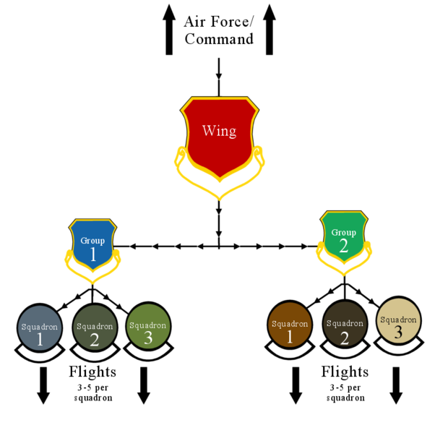

[Full resolution](http://upload.wikimedia.org/wikipedia/commons/c/c2/AFwing.png)‎ (875 × 846 pixels, file size: 82 KB, MIME type: image/png)



**Summary**

|  |  |
| --- | --- |
| **Description** | AFwing.png  Visual aid to help readers understand the difference between a Squadron/Group/Wing commander re: Featured Article on Wikipedia |
| **Date** |  |
| **Source** | Own work |
| **Author** | [Anynobody](http://commons.wikimedia.org/wiki/User:Anynobody) |
| **Permission (**[**Reusing this file**](http://commons.wikimedia.org/wiki/Commons:Reusing_content_outside_Wikimedia)**)** | See below. |

[**Licensing**](http://commons.wikimedia.org/wiki/Commons:Copyright_tags)

|  |  |  |  |  |  |  |  |  |  |  |  |  |  |
| --- | --- | --- | --- | --- | --- | --- | --- | --- | --- | --- | --- | --- | --- |
| **I, [Anynobody](http://commons.wikimedia.org/wiki/User:Anynobody" \o "User:Anynobody), the copyright holder of this work, hereby publishes it under the following licenses:**   |  |  | | --- | --- | |  | Permission is granted to copy, distribute and/or modify this document under the terms of the [**GNU Free Documentation License**](http://en.wikipedia.org/wiki/en:GNU_Free_Documentation_License), Version 1.2 or any later version published by the [Free Software Foundation](http://en.wikipedia.org/wiki/en:Free_Software_Foundation); with no Invariant Sections, no Front-Cover Texts, and no Back-Cover Texts. A copy of the license is included in the section entitled [*GNU Free Documentation License*](http://commons.wikimedia.org/wiki/Commons:GNU_Free_Documentation_License_1.2).  www.gnu.org/copyleft/fdl.htmlGFDLGNU Free Documentation Licensetruetrue |  |  |  |  | | --- | --- | --- | |  | This file is licensed under the [Creative Commons](http://en.wikipedia.org/wiki/en:Creative_Commons) [Attribution-Share Alike 3.0 Unported](http://creativecommons.org/licenses/by-sa/3.0/deed.en) license. |  | | **Attribution: I,** [**Anynobody**](http://commons.wikimedia.org/wiki/User:Anynobody) | | You are free:   * **to share** – to copy, distribute and transmit the work * **to remix** – to adapt the work   Under the following conditions:   * **attribution** – You must attribute the work in the manner specified by the author or licensor (but not in any way that suggests that they endorse you or your use of the work). * **share alike** – If you alter, transform, or build upon this work, you may distribute the resulting work only under the same or similar license to this one. | | This licensing tag was added to this file as part of the GFDL [licensing update](http://meta.wikimedia.org/wiki/Licensing_update).www.creativecommons.org/licenses/by-sa/3.0/CC-BY-SA-3.0Creative Commons Attribution-Share Alike 3.0  truetrue |  |  |  |  | | --- | --- | --- | |  | This file is licensed under the [Creative Commons](http://en.wikipedia.org/wiki/en:Creative_Commons) [Attribution 2.5 Generic](http://creativecommons.org/licenses/by/2.5/deed.en) license. |  | | **Attribution: I,** [**Anynobody**](http://commons.wikimedia.org/wiki/User:Anynobody) | | You are free:   * **to share** – to copy, distribute and transmit the work * **to remix** – to adapt the work   Under the following conditions:   * **attribution** – You must attribute the work in the manner specified by the author or licensor (but not in any way that suggests that they endorse you or your use of the work).   www.creativecommons.org/licenses/by/2.5 CC-BY-2.5 Creative Commons Attribution 2.5 truetrue |   *You may select the license of your choice.* |

**File history**

Click on a date/time to view the file as it appeared at that time.

|  |  |  |  |  |  |
| --- | --- | --- | --- | --- | --- |
|  | **Date/Time** | **Thumbnail** | **Dimensions** | **User** | **Comment** |
| current | [07:04, 24 June 2007](http://upload.wikimedia.org/wikipedia/commons/c/c2/AFwing.png) |  | 875×846 (82 KB) | Anynobody | ({{Information |Description= Visual aid to help readers understand the difference between a Squadron/Group/Wing commander re: Featured Article on Wikipedia |Source=self-made |Date= |Author= [Anynobody](http://en.wikipedia.org/wiki/User:Anynobody) }} [Category:Anynobody](http://en.wikipedia.org/w/index.php?title=Category:Anynobody&action=edit&redlink=1)) |

**File links**

The following pages on the English Wikipedia link to this file (pages on other projects are not listed):

* [1994 Fairchild Air Force Base B-52 crash](http://en.wikipedia.org/wiki/1994_Fairchild_Air_Force_Base_B-52_crash)
* [Wing (military aviation unit)](http://en.wikipedia.org/wiki/Wing_(military_aviation_unit))

**Global file usage**

The following other wikis use this file:

* Usage on de.wikipedia.org
  + [B-52-Absturz auf der Fairchild Air Force Base](http://de.wikipedia.org/wiki/B-52-Absturz_auf_der_Fairchild_Air_Force_Base)
* Usage on flaggedrevs.labs.wikimedia.org
  + [1994 Fairchild Air Force Base B-52 crash](http://flaggedrevs.labs.wikimedia.org/wiki/1994_Fairchild_Air_Force_Base_B-52_crash)
* Usage on fr.wikipedia.org
  + [Escadre](http://fr.wikipedia.org/wiki/Escadre)
  + [Accident sur la base de Fairchild en 1994](http://fr.wikipedia.org/wiki/Accident_sur_la_base_de_Fairchild_en_1994)
* Usage on it.wikipedia.org
  + [Unità militari aeree](http://it.wikipedia.org/wiki/Unit%C3%A0_militari_aeree)
  + [Stormo (unità militare)](http://it.wikipedia.org/wiki/Stormo_(unit%C3%A0_militare))
* Usage on pl.wikipedia.org
  + [Wikipedia:Tłumaczenie miesiąca/Katastrofa B-52 w bazie Fairchild](http://pl.wikipedia.org/wiki/Wikipedia:T%C5%82umaczenie_miesi%C4%85ca/Katastrofa_B-52_w_bazie_Fairchild)
  + [Katastrofa B-52 w bazie Fairchild](http://pl.wikipedia.org/wiki/Katastrofa_B-52_w_bazie_Fairchild)
* Usage on readerfeedback.labs.wikimedia.org
  + [1994 Fairchild Air Force Base B-52 crash](http://readerfeedback.labs.wikimedia.org/wiki/1994_Fairchild_Air_Force_Base_B-52_crash)
* Usage on uk.wikipedia.org
  + [Крило (ВПС)](http://uk.wikipedia.org/wiki/%D0%9A%D1%80%D0%B8%D0%BB%D0%BE_(%D0%92%D0%9F%D0%A1))